# 

UNIVERSITY OF NAIROBI

SCHOOL OF COMPUTING AND INFORMATICS

ONLINE CLOTH SHOPPING STORE

OKELLO JOB OPIYO

REG NO: P15/37353/2016

SUPERVISOR

S.N Ruhiu

June 13, 2019

A project report submitted in partial fulfillment of the Requirements of the Bachelor of Science in Computer Science.

# Declaration

This project is my original work and to the best of my knowledge and has not been presented for any other award in any university.

NAME: Job Opiyo Okello

REGISTRATION NUMBER: P15/37353/2016

SIGNATURE:

DATE:

This project has been submitted as partial fulfilment of the requirements for the award of a Bachelor of Science Degree in Computer Science at the University of Nairobi and has been done with the guidance of my supervisor.

NAME: Samuel N. Ruhiu

SIGNATURE:

DATE:

# Abstract

The purpose of this project was to come up with a system that will provide a platform that will enable shoppers to connect with designers and be able to sell their products. This will be with a main emphasis being on the shoppers ability to get clothes that are customized to give a perfect body fit. Though this has been a challenge technological advancement has enabled the use of camera and senders to achieve the same. This however is not affordable to the masses who has a low spending power. To ensure that individuals with low financial capabilities get to enjoy the same benefits, this project will employ the use of the most basic computer imaging capabilities to achieve the same fete as the virtual as the popular but expensive virtual dressing rooms found in high end clothing stores. The end result therefore will be giving the shopper the ability to enjoy the same benefits at a pocket friendly cost using resources free available at in most households and those that come embedded with most modern computers. Having shoppers buys cloth with a focus on the body fit will be of great help to the shoppers as well as the designers. This is due to the fact that it will reduce the number of sells returns that are usually a common occurrence due to wrong measurements. This will therefore ensure that we have both parties being satisfied with the transaction. The project will also connect with motorists to facilitate the transportation of the clothing brought by the shopper. At the end of the day the shopper’s satisfaction is the main area of concern since clothing have gone beyond being simple body coverings to symbols of style and prestige.

All this was to be achieved by developing a system that will enable all the users to access to the system wherever they are regardless of the device that they are using. this would be achieved by use of MY SQL, HTML, CSS, BOOTSTRAP, JAVASCRIPT. This system will use web-based technologies since web is cross platform. The technologies of development will be MySQL database, HTML, CSS, JavaScript, PHP and Bootstrap for responsive web pages.

# Acknowledgement

I am grateful to God for the good health and strength He has granted me to learn and for providing priceless people who without their effort and collaboration, this project wouldn’t be a success.

I would like to thank the following people for their contribution to my inspiration, knowledge and other help in working through this project.

1. My family for the undying support during support during the and belief in my ability to achieve the best.
2. My supervisor Mr. Samuel Ruhiu for his support and guidance and eye opening at each stage of the project.
3. My colleague Mrs. Caroline Owuor for the collaborative engagements and exposure to the industry and research work.

Contents

1

Declaration 2

Abstract 3

Acknowledgement 4

CHAPTER 1: INTRODUCTION 10

1.1 Background 10

1.1.1 Virtual Dressing Rooms Go Mainstream 10

1.1.2 How Merchants Are Adopting the Virtual Dressing Room Trend 11

1.1.3 Taking the Dressing Room Home 12

1.2 Problem Statement 13

1.3Objectives 15

1.3.1 Research objectives 15

1.3.2 System Development objectives 15

1.3 Scope 15

1.4 Justification 16

Chapter 2: Literature review 17

2.1 Introduction 17

2.2 Overview of online shopping stores 17

2.3 Virtual dressing rooms 17

2.3.2Why is this technology so important for customers? 18

2.3.3 The virtual dressing room technology 18

2.3.4 virtual dressing room cheaper alternatives 20

2.4 Preview of existing stores 21

2.4.1 Mimi Kenya 21

2.4.2 Jumia Online Stores Kenya 22

2.4.4 Mama Mike’s Online store. 22

2.4.4 Sensemi online 22

Chapter 3: Methodology 23

3.1 System Development Methodology 23

3.2 RESEARCH METHODOLOGY 25

3.2.1 Research Design 25

3.2.2 Target population and Sampling frame 25

3.2.3 Data collection methods and instruments 25

3.2.4 Data analysis 26

3.3 SYSTEM DEVELOPMENT METHODOLOGY 33

3.3.1 Requirement Specifications 33

3.3.2 System analysis and design 34

3.3.3 System coding 34

3.2.4 System testing and debugging 34

3.3.5 System deployment and Maintenance 35

3.2.6 Resources required. 35

4. System design 36

4.1 use case diagram 36

4.2 Context diagram 38

4.4 Level 1 Data Flow Diagram: Payments 40

5. Implementation and testing 44

5.1 Resources required 44

5.1.1 Hardware resources 44

5.1.2 Software resources 44

5.2 System testing and debugging 45

5.2.1 System testing 45

5.2.2 Test cases 46

5.3 System deployment and maintenance 47

6.1 Achievements 48

6.2 Constraints 48

6.3 Recommendation 48

6.4 Conclusion 48

Chapter 5: Project plan and management 50

5.1 Project activity plan 50

5.2 Project Gantt Chart 50

5.3 Required Resources 51

5.3.1 Software resources 51

5.3.2 Hardware resources 51

References 52

# CHAPTER 1: INTRODUCTION

## 1.1 Background

Clothing is one of the basic human needs that we require in our daily lives. From time immemorial people have always had to find different ways of clothing themselves and ensuring that they not only look appealing but also feel. The way an individual dress up says so much about them. Clothing has gone beyond its initial purpose of simply covering and offering protection to being a symbol of social status. This therefore means that as much as possible individual will try anything in their ability to ensure that they get the best clothes available in the market and as soon as they are available.

In the past inn order to acquire clothing one had to make the tiresome to and from the market to get their hands-on clothing. This has been and still is one of the methods that ensure one can be able to ensure that they dressed up ready for the next day’s event or simply activity. In order to ensure that most they always get the out of life many individuals therefore end up having to work up to multiple shifts a day or even be in occupations that takes most of their time leaving shopping to look like a luxurious activity due to time constraint.

Thanks to advent of technology one does not have to necessarily visit his/her local market or shop just buy a new apparel that they may desire. This is because an individual can easily carry out the same activity from the comfort of their homes. Many stores are therefore following the trend of moving their services online in order to reach a wider area of customers.

### ****Virtual Dressing Rooms Go Mainstream****

Virtual dressing room is a technological advancement that is fast growing in the fashion industry. This technology focuses mainly on providing online cloth shoppers with the ability to buy clothes and be able to try them on without necessarily having to visit the clothing stores. This technology employs the use of cameras and sensors that are used to capture three dimensional images of individuals and also use the images captures to calculate the body measurements hence ensuring that the shoppers gets clothes customized for their body fit. This new way of shopping using a virtual dressing room experience as opposed to the traditional brick and mortar equivalent has gone from exceptional to commonplace as the trend becomes more popular with retailers and consumers alike. According to[PwC’s 2018 Global Consumer Insights Survey](https://www.pwc.com/gx/en/industries/consumer-markets/consumer-insights-survey.html), 60 percent of global citizens surveyed have experienced virtual reality while shopping. Today more than ever before, individuals are asking for what they really want, and refusing to accept mediocrity in all aspects of life. You’ve heard about the plight of the millennial who wants to save the world, work flexible hours in a cool environment, and make six figures while doing it? Depending on your personal take, you might find that refreshing or frustrating. Either way, that same millennial wants to try on her lipstick before she pulls out her card, and retailers are hearing her loud and clear.

### ****1.1.2 How Merchants Are Adopting the Virtual Dressing Room Trend****

The advantages of a virtual dressing room extend to both retailers and their customers, and there’s lots of room to get creative. Take for instance Sephora a enables shoppers to try out facial beauty products lets from the Sephora Beauty stores. Users can upload close-up facial shots so that they can virtually apply anything to their unique features, from eye shadow to bronzers and blush. The app ensures customers are sure and satisfied with their decision to drop $40 on concealer. Making further use of these close-ups, the app allows shoppers to interact with the platform by watching tutorials on how to apply makeup products they might not know how to use. In this way, the beauty brand exposes customers to products they may have otherwise overlooked. This technology is also being use by other cosmetic stores such as Smash-box and Covergirl, some of the top selling beauty stores in the USA. The goal is to get would-be-buyers across the finish line with less effort while guaranteeing optimum satisfaction.

Traditional clothing retailers are following suit (no pun intended). If you’ve ever squeezed yourself into a traditional dressing room, you know they can be uncomfortable and time consuming. Whether you’re a big city shopper who tires of long lines or a rural fashionista who has to drive 30 minutes to the nearest mall, fitting rooms usually aren’t the highlight of your day. That’s why bridging the gap between a need to see how things fit and an aversion to seeing yourself bare in gas station-like lighting is starting to take off.

Gap has entered the virtual fitting room scene with an app called Dressing Room for trying on clothes before making a purchase. Users can access the app with any Google-Tango device. Customers have the ability to move their self-made avatar around so they can check themselves out from all angles in their new outfit.

Gap isn’t alone in the clothing space — several sites exist just to serve as virtual 3D fitting rooms. In these online “rooms”, window shoppers can enter their height and weight (as well as hair and eye color if the AI allows) to see how clothing will fit their exact body type.

It all comes down to customer experience — buyers want to be in control when it comes to spending their hard earned dollars.

### ****1.1.3 Taking the Dressing Room Home****

Marketers have the task of making shopping experiences more seamless, and they have become experts at creating environments that make it as easy as possible to buy.

Virtual dressing rooms are a revolutionary first step. Adding the option for deferred payments takes the experience even further. Sure, virtual dressing rooms help shoppers visualize what they’re buying, but the experience still lacks that physical, visceral touch.

With the rise of payment solutions like Klarna’s [Pay Later,](https://www.klarna.com/us/business/products/pay-later/) e-commerce merchants can offer shoppers more [payment options](https://www.klarna.com/knowledge/article/shoppers-demanding-payment-options/), including the ability to pay *after*they make a purchase. With Pay Later, shoppers can have their order delivered, test it out, and then pay for what they want to keep. That pair of jeans that looked so good in the virtual fitting room  aren’t so flattering in the stark light of reality? Send them back! You don’t need that kind of negativity.

In an e-comm environment driven by innovation and infinite options, customers are finally king (and queen) and it’s okay to act like it. Virtual dressing rooms paired with the ability to [try before you buy](https://www.klarna.com/knowledge/article/try-before-you-buy-online-shopping/) are the latest way for retailers to bring the ultimate in customer experiences.

## 1.2 Problem Statement

Clothing is one of the basic human needs, and since time immemorial buying cloths has always been an activity that was confined within markets and shopping stores. This therefore meant that to acquire a cloth one had to leave home head to the market for the purpose if shopping. the modern individual however is a person who would handle more than one job just to keep up with the harsh economic times. As a result, such individuals are deprived of time to carry out shopping. despite all of this technology has however enabled such individuals to carry out shopping from the comfort of their homes. This is enabled by stores that took on online shopping as a business model.

This however did not solve most of the problems that exist in the current market. This is due to the fact that the most of the current online shopping stores lack variety and customization. In this case we end up in the situation whereby the shoppers have to end up buying This can be owed to the fact that the stores have a fixed set of designers that supply them with their clothing merchandise. As a result, most of the local designers who are equally and even more talented are left to only sell their merchandise to a limited network of shoppers i.e. those within their locality.

To solve this issue a platform should therefore be created to allow the local designers to sign up and get an opportunity to widen the customer network and earn a living. This platform should also take advantage of the individuals within the transport sector who will also get an income earning opportunity by being able to offer their shipping services at a fee. At the end of it all we will have a satisfied customer due to having more options to choose from and designers and transporters who get to earn a living for the services that they offer.

Despite having come up as a sigh of relief for most shoppers online shopping has left out lot of areas that are yet to be addressed. These areas affect both the shoppers and the designers alike due to their nature of importance. Beginning with the shoppers as much as there is very little attention paid to the actual fitting of the cloths bought by the shopper. Most of the local shops have very little effort put into ensuring that the customer gets the cloth that fits them. Since comfort majorly influences the decision on whether or not to buy a given piece of cloth from an online store. This also contributes to a lot of purchase return which are both tiresome activities to the both the store and the shoppers.

Another issue of concern falls on the online stores and the list of designers who they choose as their clothing suppliers. Most of the local stores usually have a limited number of designers whom they have chosen as their suppliers. This therefore leaves a huge number of talented designers with the option of selling their wares only within their areas of locality. This in return denies them the opportunity to gain more market exposure and relevance hence contributing to very low sales to a limited range of consumers.

The above-mentioned problem also ripples back to the shopper. Due to a limited number of designers on the platforms the shoppers are also forced to deal with a limited variety of clothes available on the online shops. This in a way will force the shoppers to go back to the physical shopping to ensure to ensure that they get what they really desire. A system that tackles this problem is therefore required to ensure that at the both the shoppers and the designers are satisfied at the end of the day.

## 1.3Objectives

### 1.3.1 Research objectives

1. To establish an understanding on how online shops work.
2. Familiarize myself with the functioning of virtual dressing rooms.
3. To understand the process of cloth designing techniques
4. To understand technologies that are in place to ensure that the shopping process is optimized in online stores.

### 1.3.2 System Development objectives

Carry out research to get an understanding of the inner working of cloth designs and purchase.

Get an in-depth understanding of the working of Online stores.

Research on virtual dressing room and implementation technology

Carry out research on systems that existing online shopping store as well as physical stores and get their weaknesses and strengths.

Carry on survey around a targeted group of individuals with a key interest in preference when shopping online for clothing.

Design the system based on the data acquired and by the understanding reached.

Development of a system that enables shoppers to buy cloth online while getting providing through which the shoppers can get their body measurement s as part of the order.

Include a module that will enable the communication module for the parties involved in the whole process

## 1.3 Scope

This project will cover the development of a web-based application that will be aimed at achieving the following goals:

1. Give shoppers ability the ability to buy clothes from the online store regardless of their geographical positioning and have the orders being delivered at their doorstep.
2. Enable shoppers to be able to make orders on while confirming the accuracy of their body measurement.
3. Ensure that designers are able to receive and process orders from the shoppers through the store.
4. Ensure that the designers are able to reach a wider customer based all over the country.

## 1.4 Justification

With the current technological advancement and explosion of the internet globally, Kenya is of the countries that is enjoying the benefits of such advancements with above 60% of its population having access to the internet and other technologies that seem to make the world a global village. This therefore means that at least 6 out of every 10 Kenyans have access to the internet services. This is further boosted with the mobile phone penetration with over 80% of the population having access to mobile phones and other computing devices. Having this knowledge in mind we can therefore observer that a web-based shopping would be a perfect fit as a technology to deploy our online store. This is due to the fact that website can be accessed across all devices and across all technologies used to deploy mobile services. This there means that whether an individual is on IOS, Android, Linux and Windows device or using a smartphone, tablet, desktop or laptop computer, the individual will still be able to gain access to the shopping services.

# Chapter 2: Literature review

## 2.1 Introduction

This chapter aims at taking a look at the current online shopping that mainly focus on clothing as their main product. The problem statement highlighted in chapter on will be looked into in more detail with respect the existing stores selling cloths using the various online platforms available. The chapter will consider the factors affecting customers as they make their purchases from these stores. The various issues facing the online stores will be analyzed and be used to point out the various issues the online stores. The knowledge acquired from this chapter will then be used to form the basis of strength and uniqueness for the online stores that is to be developed in this project. This will also enable the business to have better operational model that will ensure a higher return on investment and within a short period of time.

## 2.2 Overview of online shopping stores

In today’s world the average adult is most an employee who spends a better part of his day at the work premises. This therefore leaves such an individual with very little time to carry out other personal activities such as shopping. Thanks to the evolution of technology and the rise of the internet, this individual is now able to carry out shopping for most of the daily items that they might need in their household from the comfort of their homes. This comes even more handy in the busy holiday season where the individual only is saved from the trouble of waiting in long queues and having to bother with the opening and closing of the stores since online stores are open 24 hours a day. Another interesting thing about online clothing stores is that the customer is able to find a huge variety of items from the same store, somethings that would have require them to move from shop to shop if they were shopping manually. In the next sub section, we will a look at the virtual dressing rooms as well as the existing online stores in the country such Mimi Kenya, Jumia Kenya and Mama Mike’s Online store.

2.3 Virtual dressing rooms

Virtual changing rooms have technically been available for a while but so far, they have not been generally adopted by retailers. If we are to believe all the hype virtual changing rooms are the silver bullet for fashion retailers and totally revolutionize how we shop for clothes both online and instore. So why the hype?

2.3.1 Virtual changing rooms will reduce costs for fashion retailers  
  
The changing rooms are an area of stock loss and are always a high staffing cost, while online customer return 25 percent of purchased clothing with 70 percent being for the wrong size. This type of experience is an area of concern as it results in both the loss of revenue for the sellers and the dissatisfaction that comes with buying clothes that do not fit for the shoppers. This will therefore slowly but surely push the shoppers back to the traditional and tiresome physical shopping which apart from being time consuming can also be tiring with the only advantage being the ability of the shoppers to get the clothes the clothes that fit them before finalizing their purchase.

2.3.2Why is this technology so important for customers?  
Just imagine you are about to go out to a special event and cannot find the right outfit. Today it’s a real challenge, but tomorrow you go to your favorite retailer’s website try on a number of outfits via their virtual changing room. They will already have your size programmed and you order. Two hours later, yes two hours later, it’s at your home and you are having the outfit you need. This will be fashion retail of tomorrow. With this type of ability in one’s hand, one has less worries to keep in mind and more time to invest in other important activities as technology handles the shopping.

2.3.3 The virtual dressing room technology  
Virtual fitting rooms normally create a mannequin so shoppers can see how different sizes may fit their shape, by customers simply entering some basic measurements and a virtual mannequin adjusts to fit their dimensions. The customer then can then dress the mannequin with different sizes, allowing them to see how different garments will fit before making their purchase. There are different technical solutions which is making it far more challenging for retailers to pick one.

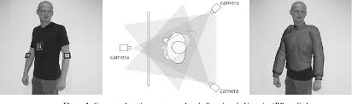

These methods include:

1. **Body scanners** – This technology comes in two distinct flavors: scanners that use technologies such as webcams, phone cameras, or Microsoft’s [Kinect](http://en.wikipedia.org/wiki/Kinect) device and scanners that uses some more sophisticated technologies requiring the shopper to travel to the scanner. Web and phone camera technologies require users to stand a fixed distance away from the camera and to hold a standard-sized object (such as a CD) that the camera can use as a reference for size. The more sophisticated scanners that use [laser](http://en.wikipedia.org/wiki/Laser) or [millimeter wave detector technology](http://en.wikipedia.org/wiki/Extremely_high_frequency), or even multiple arrays of Kinect sensors, are too bulky and expensive to be used in most stores and are located instead in shopping malls or in large department stores. Customers are required to visit the location to be scanned and this information may then be used on online sites.
2. **3D fitting rooms** – These use computer-generated 3D images to create an experience similar to that seen in [virtual world](http://en.wikipedia.org/wiki/Virtual_world) computer games. These solutions generate a virtual mannequin (avatar) using customer body measurements and shape information. An avatar of the shopper is created, this requires the shopper to measure himself or herself and provide these data. Sometimes the avatar may be personalized: racially, or by skin tone, or by application of pre-determined hairstyles, or even by uploading an image of a customer’s own face. The avatar may then be used to show how the shopper would look wearing the clothing, accessories and any other items on sale. Versions that are more sophisticated allow side-by-side comparison of different versions of a garment, and enable different items to be tried on at the same time.
3. **Fitting room with real 3D simulation** - Real 3D Simulation fitting room combines the features of 3D solutions and photo-accurate fitting rooms. Using a combination of photo and simple body measurements, the solution generates a 3D mannequin, which accurately visualizes customer in chosen apparel items. Normally, the system suggests an appropriate size for entered measurements, but customer can also choose other sizes to estimate their fit.
4. **Augmented reality** – Most Augmented Reality Virtual Dressing Room solutions work by superimposing the 3D model or picture of a garment or accessory within the live video feed of the customer. The superimposed 3D model or picture of the garment or accessory will then track to movements of the customer so it appears as if the customer is wearing the virtual item in the video view. Augmented Reality Virtual Dressing Rooms usually require a desktop webcam, a smartphone camera or a 3D camera, such as Kinect, to function. An example of Augmented Reality utilized for Virtual Dressing Rooms includes use of a 3D camera to manipulate areas of a garment or accessory within a display.
5. **Photo-accurate virtual fitting rooms** - This technology is a convergence of two techniques: using real models and dress-up mannequins. Instead of photographing garments on people similar to customer’s shape and size, images are made using shape-shifting, robotic mannequins. The computer-controlled mannequins quickly morph through a series of body shapes and sizes while garments in each different size are photographed and the image stored in a database together with the measurements that generate the image. Since the mannequins are computer-controlled, the whole process is relatively fast. In the final version, the mannequin is edited out from the photography and replaced with a virtual avatar, which can be changed to reflect the brand involved. Once a customer inputs their measurements into the systems, the image in which the mannequin has the same measurements as the shopper is retrieved from the database and shown to the customer. (Register, 2018)

Technology is advancing fast and delivering many different options, so it’s clear that technology-based companies believe virtual dressing rooms are worth the investment. Which technology is best is still open to debate, but the best technology does not always determine the winner? It’s a combination of financial investment, marketing, and most importantly - user experience.  
   
The failure to adopt this technology will only be acceptable for the discounters and value retailers. The big question for fashion retailers is which one to choose and for this, all fashion retailers would do well to take independent advice.

## 

### 2.3.4 virtual dressing room cheaper alternatives

Despite virtual dressing room being a revolutionary way of handling online apparel shopping, the technology is still basically an expensive venture for a large population of the retailers and shoppers alike. This is due to the fact that the developers will have to deal with the hustle of affording very expensive equipment. As a result, the retailers will therefore be forced to increase the prices to the apparel so as to be able to carter for the cost incurred in the retail process. Shoppers under the pressure will also be forced to take on the only close and viable option which will be going back. To the traditional form of apparel shopping. this constraint can however be overcome if a cheaper alternative will to this technology is used. To achieve this, I will therefore use the readily available webcam that comes with a majority of the modern laptops and desktop computers alike. This will work by taking the image of the individual alongside a common object which will be in the background. The body measurements of the individual will therefore be calculated in relation to the reference object in the image.

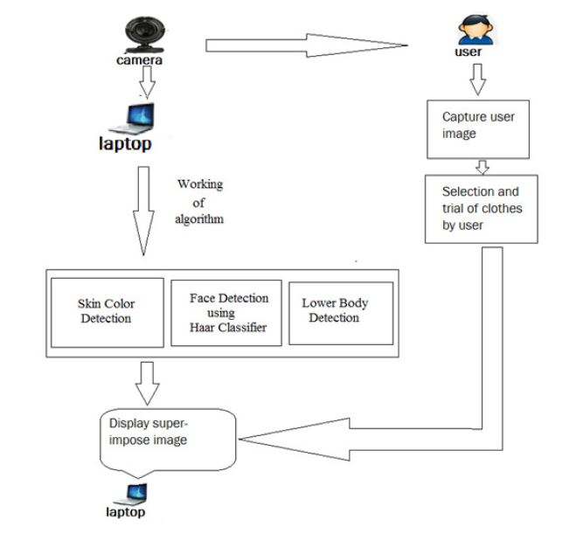

For most parts of the measurements the linear formulas will be used to achieve the results. For the waist however a special mathematical formula known as the Ramanujan algorithm will be used to calculate the results. This formula is quite common in the field of computer vision as it is one the algorithms used by the other virtual dressing platforms such as the famous Microsoft’s Kinect Kit, a major component in the implementation of most virtual dressing rooms. This formula will assume the elliptical shape of the human waste as illustrated in the image below. The first measurements (a,b) will be obtained from an individuals images and then matched to a reference object. In our case, a standard A4 envelope will be used.

Ramanujan algorithm

1. The first step will involve getting the measurements ‘**a’** and ‘**b’.**  This two will be obtained from the individuals photo facing forward and also while facing sideways.

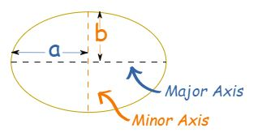

1. We will then use it to calculate another variable “**h”** as shown below.

h = (a-b)^2/(a+b)^2

1. The last step will then be using the variable “**h**” to finally calculate the perimeter. As shown below

ellipse perimeter approx pi(a+b)(1 + 3h/(10+sqrt(4-3h)))

This algorithm is quite effective since it will only give an offset of **-1 to +1**  **inches** when rivaled against dressing room running the Kinect Kit Set up.

## 2.4 Preview of existing stores

### 2.4.1 Mimi Kenya

Mimi online store’s offices are located in Nakumatt road, Kahawa Nairobi and First floor, Avenue House. Mimi influences the fashion Kenyan ladies take especially the middle class where the targeted average dresses is about 3000.Delivery is done well as long as you wait their delivery days. It is also one of the Kenyans leading selling of clothes through her dressing attracts and her general popularity. This effectively makes her store get return on investment within a short period of time where she gets ten compliments and dressing suggestions on her social media after every Sunday live. Due to its high running cost and maintenance customers would have to pay much more for venture for their merchandise and this may make ladies who are below middle not to shop there. Also, when one is delivered a dress, she may find it is not of her size and eventually result in a sell return (Fashinza, 2019)

### 2.4.2 Jumia Online Stores Kenya

Jumia offline stores are in Nairobi CBD Emperor Plaza, Kenyatta Avn. Opp. GPO. It is an open business-to-consumer platform enabling business to reach Africa’s vast and growing consumer market. It has established itself as the destination for quality, branded products, catering and to an increasingly sophisticated African consumer(s). Their growth is largely influenced by the professionalism and carrier growth of their employees which they have backed with test practices and effective knowledge transfer from across the globe.. When shipping in Jumia shopping store, making payment means accepting delivery. Therefore, it is not possible to open products bearing manufacturers seal, reject and send them back with the same driver if the product is oversize or smaller .it can only be returned if you haven’t opened and allow the return policy. For the ones overseas or anyone who wants to return, one will incur an extra shipping fee of ksh.100 when returning. This alone does sound like good news to an individual who wanted to purchase a cloth online and as a result may resolve to buying cloths from local physical stores (Gacheru, 2015)

### 2.4.3 Sensemi online

This is a Dubai based that also deals in online clothe purchase. Different from the above-mentioned Kenyan stores Sensemi has been able to introduce the concept of virtualized dressing rooms into their stores. Their stores have fitting rooms that contain digitalized fitting rooms with screens solely dedicated to only enable customers to get a feel of what would feel like once they will they have bought the cloth. This has enabled them to reduce the numbers of purchase returns as well as helped improve the shopper’s decision-making process before a purchase is made. This however only constrains the shoppers to always have to visit the shop in order to be able to try out the clothing virtually.

# Chapter 3: Methodology

## 3.1 RESEARCH METHODOLOGY

This is the manner in which a problem to be solved through the creation of a new system will be identified and given a logical sequence of steps that will contribute towards the solving of the problem at hand. In our case the internet will serve a great purpose in identifying the existent systems and their shortcomings which will play also enable the creation of an enhanced system. In the instances where further clarity is needed the owners of the existing systems will be contacted for more information.

### 3.1.1 Research Design

This is the general nature of the method used to carry out research for the development of a new system. In this case the knowledge of existing systems will be quite essential in mapping out the how the new system will be built so as to make the system more efficient than the existing ones.

In this case, questionnaire was the main method that was used in the collection of data. The questionnaire was designed based on the knowledge of existing systems that are currently carrying out online retail of cloths to shoppers. The questionnaire was distributed to the respondents with an aim of identifying the functioning of the existing systems, the weaknesses and also the profiling of the shoppers themselves.

### 3.1.2 Target population and Sampling frame

The questionnaires were distributed to 64 respondents within different locations including the campus. The respondents were chosen based on their availability and their willingness to answer the questions given to them. This exercise was in accordance with the quantitative data collection procedure. Most of the respondents were also chosen based on their age in that there all had legal consent to carry out purchase shopping from stores that offered online retail services. This therefore meant that their ages were ranging from the ages of 18 years to 70 years of age.

### 3.1.3 Data collection methods and instruments

The most suitable method of data collection in the research were the use of questionnaires. Through the questionnaire a survey of the target population on their interaction with online shopping services was carried out. The questionnaire was divided into two parts. The first part was focused upon the users themselves. This helped in collecting demographic information such as age and gender of the respondents for the purpose of population profiling. The second part of the questionnaire was focused on the existing similar systems carrying out online retail services. The questions on this part of the questionnaire mainly focused on the respondent’s experience while shopping online for clothes. This also gave data that enabled the looking into the system and be able to spot the areas of weakness in the systems and come up with a better system. From the data collected from the questionnaire the following analysis was able to be carried out and enabled to me to gain insight on both the

### 3.1.4 Data analysis

After the data collection was done through the questionnaire was done, an analysis was carried and the following results were obtained according to the questions asked in the questionnaire. This analysis was carried out using the descriptive statistical analysis for the preparation of the averages using graphs and frequencies.

1. **Demographic analysis**

According to the demographic collected from the respondents using the questionnaires it was found that 55% of the respondents were male while 45% of the recipients were female.

The majority of the respondents making up 64% were also found to be in the age bracket of 21 – 25 years of age, followed by 16-20 years and 26 – 30 years age brackets. This goes further to imply that a good majority of the tech survey population brackets find it easy to carry out shopping online as compared to the older generation of individuals.

This also went in hand in hand with the fact that the 58% of the respondents were college students. The respondents were also found to be reluctant in shopping online as 50% of them shopped online while the remaining portion preferred to shop online for goods at least once in a month.

Despite all that a majority of the respondents still gave the online shops a preference over the normal physical shopping.

1. **Existing system analysis**

When it came to the experience with the existing system the respondents still gave online shops a preference to the traditional shopping methods. The respondents also placed the quality of clothing as the main reason as to why they would opt to buy clothes from online stores as shown by 49% of their responses.

Though the respondents still liked shopping for clothes online they still preferred to pay for the purchase cloth items upon delivery as opposed paying online before the product is delivered as shown by 87% of their responses.

The respondents also wanted their purchased items to be delivered at their homes instead of the agreed pick stations set up by the stores as seen in 64% of the responses.

Smartphones and laptops were also found to be the main prefers device for carrying out shopping due to portability and the ability to access online store applications and websites as shown through 66% of the responses.

When it came to spending most of the respondents were found to have spent between ksh. 1000 – 5000 while shopping online for clothes as shown by 71% of their responses.

These respondents also stated that their shopping while online was not out of the spur of the moment as is commonly believed but planned as shown by 71% of their responses.

Despite having so much confidence in online stores 43% of the respondents would still try and makes comparison of their purchase with local offline clothing stores.

When it came to taste and customizations the respondents 71% of the respondents still preferred to have customized clothing before purchasing them.

## 3.2 System Development Methodology

This project will make use of the rapid development methodology. This methodology primarily focuses on the following activities

1. Requirement analysis – this phase focus mostly on the data modelling for the system to be created. The output in the data modelling will be very essential in determining which the overall build of the system. Data objects are defined to model the information flows identified in this phase. This phase will enable the determination of characteristics and relationships amongst data objects.
2. Design – once the requirement modelling is done the design process will then enable the business processing model in which the data models will be used to come up with a well-defined information flow of the system.
3. Prototyping – this phase will the focus the attention on building up the most critical components of the system in a repetitive and incremental manner. The process will enable the identification of any constraints of the system in the early stages of development hence give room for the correction while getting user feedback.
4. Testing – once the prototype is complete the final system will they be built from the prototype and then be deployed to the various users for the purpose of testing.
5. Implementation – once the user has tested the system and verified that all functionalities are good to go, the system will then be finally launched for use.

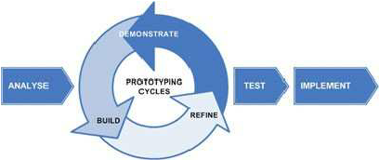

Why use RAD?

1. Changing requirements can be accommodated.
2. Progress can be measured.
3. Iteration time can be short with use of powerful RAD tools.
4. Productivity with fewer people in a short time.
5. Reduced development time.
6. Increases reusability of components.
7. Quick initial reviews occur.
8. Encourages customer feedback.

* Integration from very beginning solves a lot of integration issues.

### 3.3.1 Requirement Specifications

**Functional requirements**

The system should be able to meet the following functional requirements:

1. The system should enable users to create accounts and be able to carry out their roles i.e. shoppers, Designers and transporters.
2. Designers should have the ability to also create their own account s and be able to display their merchandise.
3. The system should have a mechanism of communication between the shoppers and the designers.
4. The system should enable the shoppers to make payments for their service and also enable the payment of the designers and the transport facilitators upon the completion of each purchase.
5. The system should enable the client to view the list of available designers and their products.
6. The system should enable the shoppers to be able to keep track of their purchases while designers keep track of their sales.
7. The system should also have a mechanism of enhancing the navigational capabilities of the transport facilitators during the delivery of the purchased goods.

**Non-Functional Requirements**

The system should be able to meet the following non-functional requirements:

1. **Usability –** the system should have a user-friendly interface for ease of use.
2. **Security –** the system should be able to guarantee the safety of user data and security of each transaction.
3. **Reliability –** the system should be accessed all 24/7 with less technical requirements
4. **Flexibility –** the system should be accessible from any device regardless of the operating system and hardware architecture.
5. **Accuracy –** the system should be accurate in terms of data inputs and outputs for all users.

### 3.3.2 System analysis and design

The system will be broken down into two parts:

1. **The front end** – this will be the website which the users will be interacting with. It will be composed of several webpages based on the user’s activity in the system.
2. **The back end** – this will be the part of the system that will be made up of the system’s database and be responsible for carrying out data processing.

The design of the system in terms of data flow will be represented using data flow diagrams and entity relationship diagrams.

# System Analysis

# 4.1 use case diagram

Use case models give high level description of system by outlining the interaction between the users of the system and the system itself. This enables the modelling of the systems functionalities to the system requirements collected during the requirements stage of the system development life cycle. Use case diagrams use cases which are the various functionalities of the system and the actors who are the entities that interact with the various uses cases found in the system

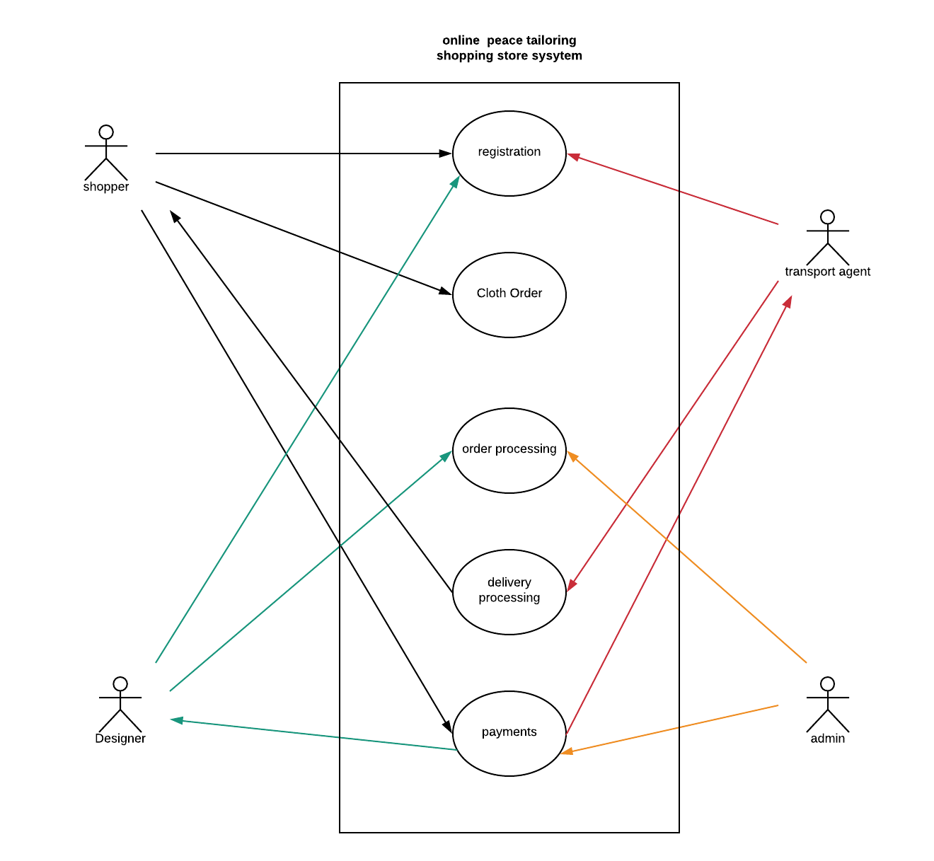

Figure 1Use Case diagram

The table below shows the Use Case diagram description with respective actors.

|  |  |  |
| --- | --- | --- |
| **Use Case** | **Actor** | **Description** |
| Registration | Shopper, designer and transport agent | This enables all the users to create account in the system and carry out their respective roles in the system. |
| Cloth order | Shopper | This allows the shopper to views the available clothing and therefore make an order based on his or her preferences. |
| Order processing | Designer, system admin | This enables the designers to accept the order from the shopper and produce a final product as per the shopper’s requirements. |
| Delivery processing | Transport agent | This allows the transport agent to receive the completed cloth orders and deliver them to the shopper’s premises. |
| Payments | System admin, Shopper, designer and transport agent | This allows both the designers and the transport agents to get payment once an order has been completed. It also allows the shoppers to get refunds on return of the purchases if they were not satisfied. |

Table 1 Use Case Table

## 4.2 Context diagram

This a diagram showing the main process that the system performs. The diagram gives the main entities of the system and the data flow into and out of the system. The rest of the component processes of the system are not displayed but hidden within the main process which is the process 0.

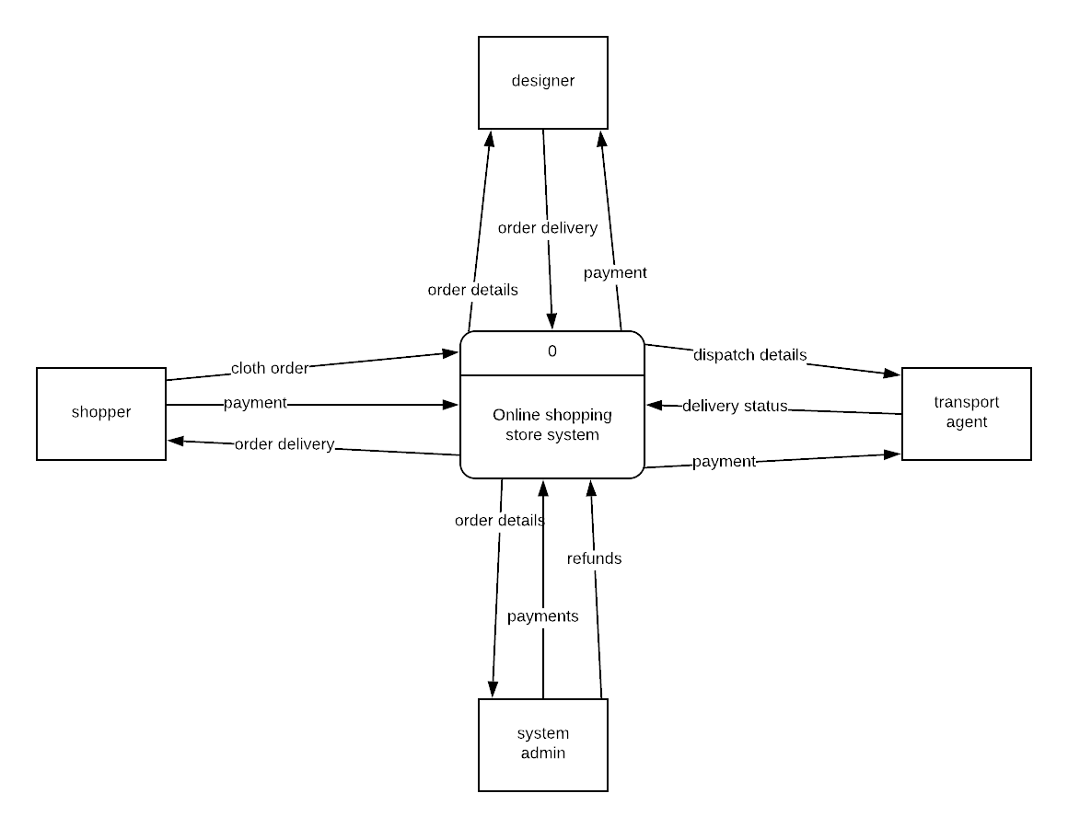

Figure 2Context Diagram

**4.3 Level 0 Data Flow Diagram: All system processes**

This is dataflow diagram that explodes all the major processes of the system associated with all the data flows and data stores in the system as the users of the system get to interact with the system.

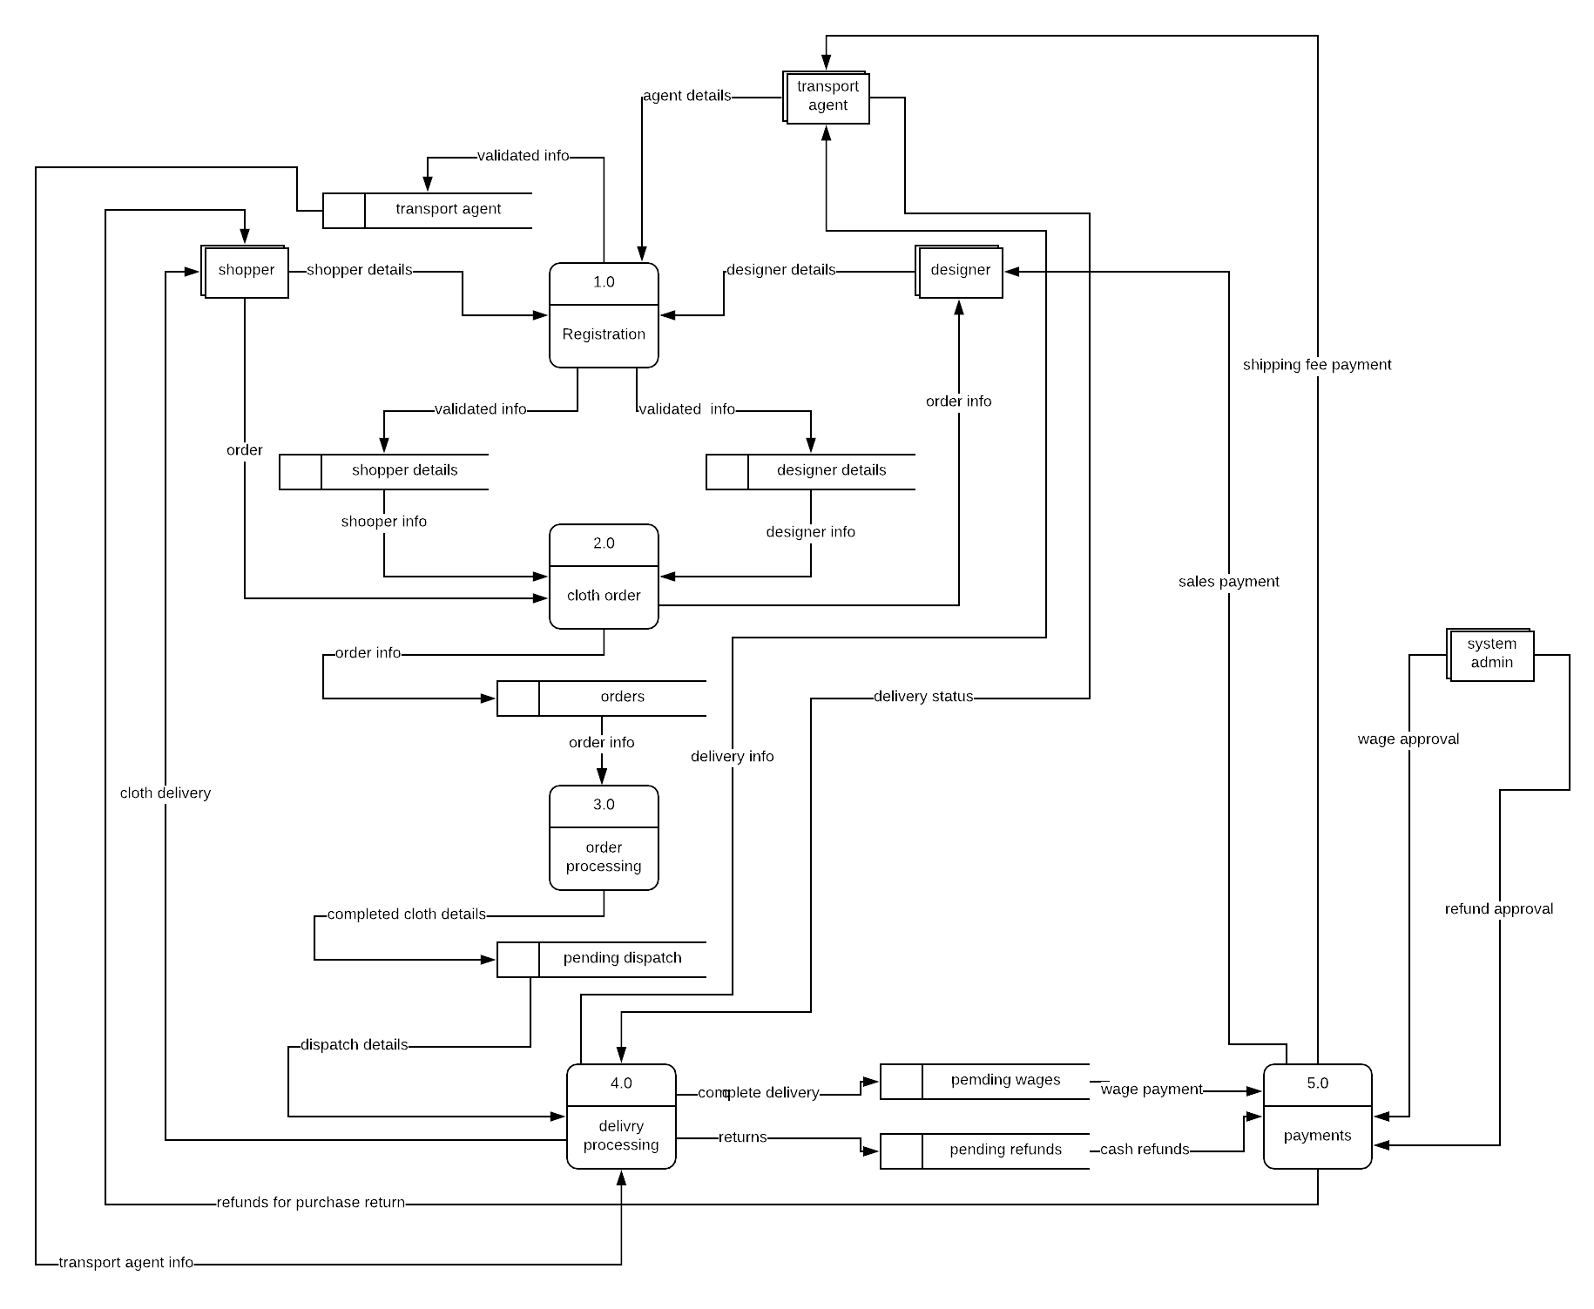

Figure 3 Level 0 DFD

## 4.4 Level 1 Data Flow Diagram: Payments

This is a diagram that explores one of the processes in the system as shown in the level 0 DFD at a more detailed manner. This just like the rest gives the entities involved, data flow, data stores and process after the breakdown of the of the process. This diagram explores the payment process from the level 0 data flow diagram.

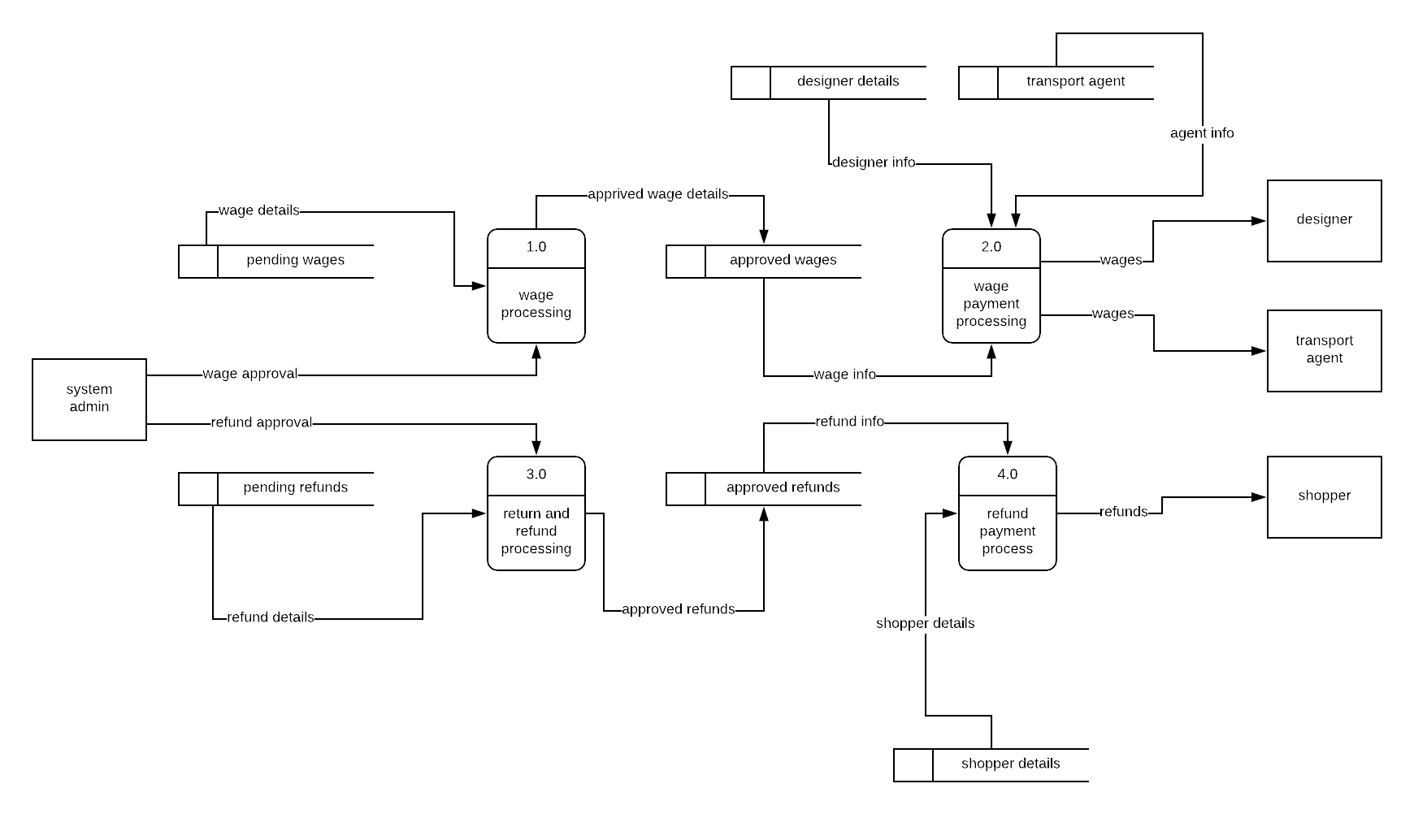

Figure 4 Level 1 DFD

# 5. System Design

## 5.1 Database Design and Entity Relationship Diagram

**Entity relationship diagram**

An entity relationship diagram (ERD) shows the relationships of entity sets stored in a database. An entity in this context is an object, a component of data. An entity set is a collection of similar entities. These entities can have attributes that define its properties.

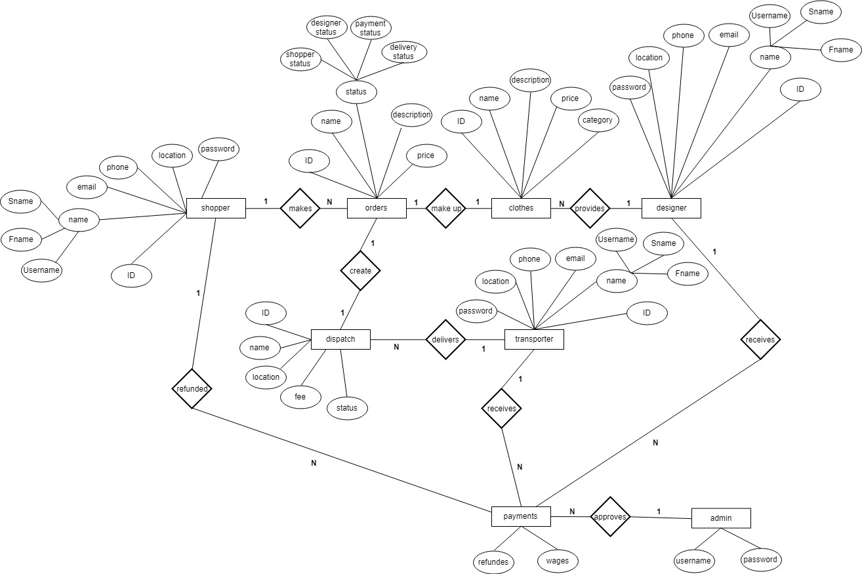

**5.2 Database design**

This is diagram that gives a diagrammatic representation of the system’s database. When the users of the system get to interact with the data entered or generated by the system is stored in the systems database with their relationship being as depicted in the figure below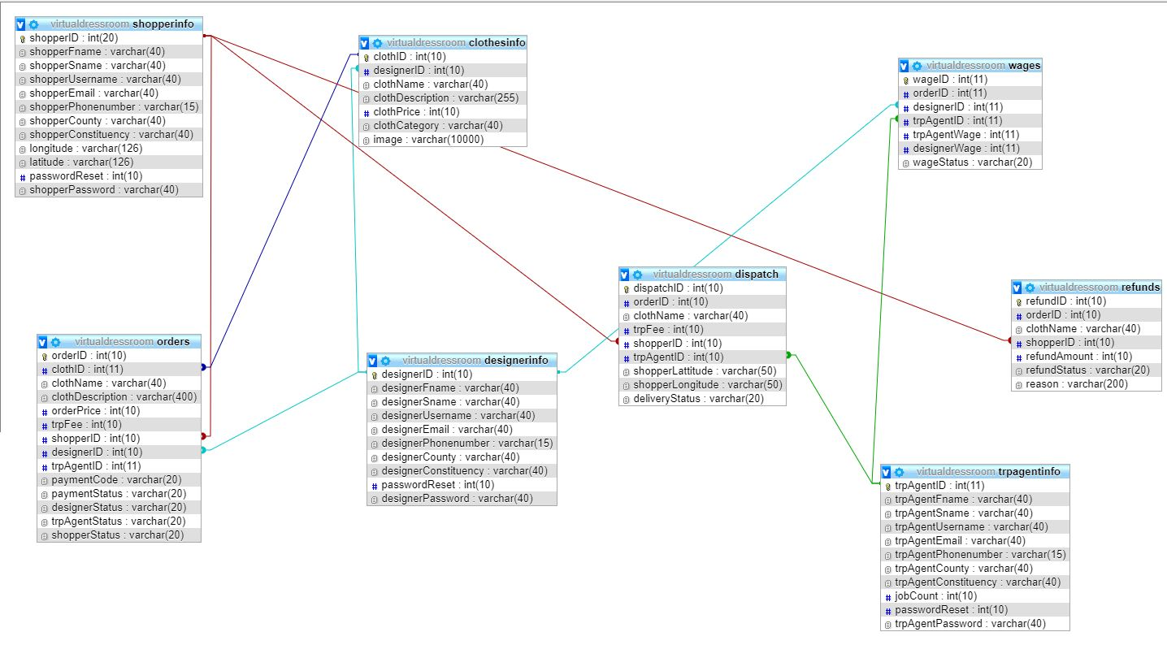

# 5. Implementation and testing

## **5.1 Resources required**

The system will be developed using the following hardware and software resources.

### **5.1.1 Hardware resources**

The computer that will be used to develop the system will have to meet the following requirements:

1. 4 Gigabytes of RAM.
2. 300Gigabytes of storage space.
3. 1 Gigabytes of dedicated graphics card memory.
4. 2Hz CPU processing speed.

### 5.1.2 Software resources

The following software tools and scripting languages will be used to develop the system to completion:

1. **WAMP server-**this will be the localhost software for the system.
2. **PHP storm-** this is the integrated development environment that supports HTML, CSS, JavaScript and PHP scripting languages.
3. **MYSQL-** this will be the software where the system’s database will reside.
4. **Google chrome browser-**this will be the testing browser for the system.
5. **Window 10 operating system-** the operating system upon which the system will be deployed.
6. **HTML and CSS-** languages for the front-end design of the system’s webpages.
7. **JavaScript-** language for enhancing interactivity and data entry validation on the webpages.
8. **PHP-** the language for connecting the webpages to the database of the system.
9. **MySQL-** the language implementing the system’s database.
10. **Google maps API-** application programming interface for aiding the navigation capabilities during the communication of the systems users

## 5.2 System testing and debugging

### 5.2.1 System testing

After completing the development of the system, testing will be done in order to ensure that the system function as expected. The testing will be done in the following terms:

1. **Unit testing-** This will involve testing each module in the system for any error during performance.
2. **Integration testing-** This will involve the testing of how different the system will work when combined to work on a given task in the system.
3. **Data validation and expectation testing-** This will be done by entering both correct and incorrect data input into the system so as to see how the different modules will process data even in exceptional situations.
4. **System testing-** When all the above stages of testing are completed, the system will be tested before being deployed.

### 5.2.2 Test cases

Test cases identify and communicate the conditions that will be implemented in test and are necessary to verify successful and acceptable implementation of the system’s requirements.

|  |  |  |  |  |  |
| --- | --- | --- | --- | --- | --- |
| **Test case** | **Module (Process)** | **Description** | **input** | **Expected results** | **Actual output** |
| 1 | Registration | This enables the shopper, designer and transport to create individual accounts. | Enter valid personal details. | Success message and redirection to login page. | Success message and redirection to login page. |
| Enter invalid personal details. | Error message displayed and prompt re-entry of personal details. | Error message displayed and prompt re-entry of personal details. |
| 2 | Cloth ordering | This enables the shopper to evaluate cloths from different designers then deciding on which one to buy. | Selecting a cloth and adding to cart | If cloth is in stock it will be added to cart and await payment. | If cloth is in stock it will be added to cart and await payment. |
| 3 | Order processing | This enables the designer to work on the order placed by the shopper | Designer enters confirmation for the orders cloth. | Success message with update of on the designer’s confirmation and emailing the shopper on the successful completion of the cloth order. | Success message with update of on the designer’s confirmation and emailing the shopper on the successful completion of the cloth order. |
| Designer cancels the cloth order. | The order will be deleted, and the shopper be notified of the cancellation. | The order will be deleted, and the shopper be notified of the cancellation. |
| 4 | Order delivery | This enables the transport agent to be transport the clothing package once the designer has finished preparing the order | The transport agent enters the delivery confirmation of the to the shopper | Shopper notified of the delivery of the cloth order and also confirms the delivery by him/herself. | Shopper notified of the delivery of the cloth order and also confirms the delivery by him/herself. |
|  | The transport agent cancels the delivery or does not give the confirmation of the delivery. | The shopper does not get delivery confirmation and therefore has to wait until order is delivered or contacts the admin. | The shopper does not get delivery confirmation and therefore has to wait until order is delivered or contacts the admin. |
| 5 | Payment | This enables either the payment of the designer and the transport agent on the completion of an order by the shopper. A refund on the event a failed order. | Confirmation of order delivery by the shopper. Confirmation of dispatch delivery by the transport agent. Confirmation of cloth finished order preparation by the designer | If all the parties confirm the completion of the order, then the designer and the transporter will be paid in terms of wages and transport fees. | If all the parties confirm the completion of the order then the designer and the transporter will be paid in terms of wages and transport fees. |
| If any or all of the parties don’t confirm the completion of the order then the shopper will be refunded for the failed delivery | Shopper will be refunded for failed delivery. | Shopper will be refunded for failed delivery. |

Table 2 Test Case Table

## 5.3 System deployment and maintenance

After completion of the debugging phase of the system development life cycle, the system will then be deployed to a few users for testing for a given period of time so as to get the overall response on the system from users. The feedback from the users will then be used to tweak the system further in order to fit the overall user liking.

**6. Conclusion and Recommendation**

## 6.1 Achievements

The successful completion of the project produced a working system based on the previously listed design specification and conceptual model. The working model was able to meet the following user requirements:

1. Users were able to create their account according to their roles in the system i.e., shoppers, designers and transporters.
2. Shoppers were able to evaluate cloths and make purchases from a wide collection of designers
3. Designers were able to put out their designed clothes and accessed shoppers from all over the country
4. All users of the system were able to be notified by email throughout the order processing period.
5. The shoppers were able to make purchases and the designers were able to be paid for their services.
6. The system enabled the shoppers to be refunded incase an order was not completed successfully.

## 6.2 Constraints

Despite the successful completion of the project and the production of a working system, a few challenges were met and this hindered the full implementation of some functionalities of the system. This challenge includes:

* The acquisition of an M-Pesa pay bill account number was hindered by the high cost hence the payment process in the system had to be simulated through the system’s database.

## 6.4 Conclusion

The main aim of this project was to develop a web-based system that would allow the shoppers to be able to book buy clothes and assure that the designers and motorists obtain standard salary and get to earn a living. This project has been successfully completed and will go a long way changing the current operations in regards to the online shopping for clothes.

## 6.3 Recommendation

This web application can further be reviewed further and be developed into mobile app for optimization.

# References

Africa, S., 2019. *Sensemi stores.* [Online]   
Available at: http://sensemi.com/mysa/  
[Accessed 8 January 2019].

Fashinza, 2019. *Virtual Fashion Items Vs. Traditional Fashion.* [Online]   
Available at: https://fashinza.com/textile/tips-for-fashion-brands/virtual-fashion-items-vs-traditional-fashion/

Gacheru, M., 2015. *What the Shopping Experience On Jumia Kenya Is Like.* [Online]   
Available at: https://techweez.com/2015/03/06/shopping-experience-on-jumia-kenya/

Mumo, M., 2018. *How many Internet users are in Kenya?.* [Online]   
Available at: https://www.businessdailyafrica.com/corporate/tech/How-many-Internet-users-are-in-Kenya/4258474-4259072-htn83lz/index.html

Ngethe, S., 2018. *Sharing Love, Spreading Happiness: Mama Mike’s Online Store.* [Online]   
Available at: https://www.africaontheblog.org/sharing-love-spreading-happiness-mama-mikes-online-store/

Register, T., 2018. *virtual dressing rooms.* [Online]   
Available at: https://theregister.co.nz/news/2015/06/virtual-changing-rooms-will-revolutionise-fashion-retail  
[Accessed 8 january 2019].

# Appendices

## Appendix A: Questionnaire

|  |
| --- |
| **ONLINE SHOPPING STORE**  **QUESTIONAIRE**  Hello this is a conducting a survey based on the Peace Tailoring online shopping store platform. Kindly go through the questions and give your answer by ticking the appropriate circle. Feel free to ask for assistance/clarity at any given point.  **Part A: People**   1. What is your gender?  * Male * Female  1. What age bracket do you belong to?  * 16 – 20 years * 21 – 25 years * 26 – 30 years * 31 – 35 years * 36 – 40 years * 41 – 45 yeas * 46 – 50 years * Above 50 years  1. What is your current employment status?  * Unemployed * Student * Full-time employee * Part-time employee * Self employed * Retired   **Part B: Context**   1. How did come to know of Peace Tailoring Online Shopping store?  * Through friends * Online invitations * Newspaper advertisements * Links on social media platforms i.e., Facebook, WhatsApp, Twitter  1. How often do you buy goods online?  * Once a week * Multiple times in a week * Once in a month * Multiple times in a month * Rarely  1. Rate your preference of online shopping to traditional physical shopping?  * 1 * 2 * 3 * 4 * 5  1. Which of the following Influenced your decision above?  * Product price comparison * Quality of products * Large variety of products * Large pool of suppliers * Mode of payment * Time factor * Mode of product delivery * Ability to keep up to date with market trends   **Part C: Activities**   1. Where do you usually take inspiration for new purchase?  * Family * Friends * Celebrities * Fashion magazines * Events * Trends on social media  1. Which of the following will influence your decision while shopping for clothes from online store?  * Product pricing * Product quality * Product branding * Mode of payment * Mode of delivery * Color * Material * Style * Comfort  1. Which mode of payment do you find more convenient while shopping online?  * Online payment (before delivery) * Pay on delivery  1. Which mode of delivery would you prefer for a product you just purchased online?  * Home delivery * Pick-up stations   12. Which platforms give you optimized user experience while shopping online?   * Store websites * Smartphone application  1. Which device gives you the most enjoyable shopping experience on Jumia?  * Smartphones * Tablets * Laptops & desktops computers  1. What are the major challenges that you face or have faced after purchasing clothing from an online? 2. Briefly describe any additional features and improvements that you would like stores to make so as to improve your shopping experience   **Part D: Technologies**   1. How much would you spend to purchase a clothing from an online store  * Below ksh.100 * Ksh.100-500 * Ksh.500-1000 * Ksh.1000-5000 * Above Ksh.5000  1. Are your purchases usually planned or spur of the moment?  * Planned * Spur of the moment * Either  1. When purchasing a new item, do you buy a matching outfit item?  * Sometimes * Quite often * All the time * Not often * No never  1. Who do you mainly shop with?  * Alone * Family and friends * Partner * Colleagues * Choice 5  1. When shopping for clothes, do you:  * Decide to go in due to the window display/adverts * Try new shops * Search beforehand for information and then visit the right store for me * Go to shops where there are special offers * Others  1. Do you prefer any customizations on the clothes that you purchase?  * Yes * No  1. Rate your experience from shopping for clothes from online stores.  * 1 * 2 * 3 * 4 * 5   Kindly sign in the given slot below:  **Thank you for your time.** |

## Appendix F: Sample Codes

shopperRegistration.php

|  |
| --- |
| <?php  //gives variable for creating the connection  $servername = "localhost";  $username = "root";  $password = "";  $dbname = "ivyproject";  // Create connection  $conn = new mysqli($servername, $username, $password, $dbname);  // Check whether the connection was successful  if ($conn->connect_error) {  die("Connection failed: " . $conn->connect_error);  }else  echo "Connected successfully";  //check whether each data item was picked from the form successfully  if (isset($_POST['fName'])) {  $shopperfName = trim($_POST["fName"]);  }  if (isset($_POST['sName'])) {  $shoppersName = trim($_POST["sName"]);  }  if (isset($_POST['username'])) {  $shopperusername = trim($_POST["username"]);  }  if (isset($_POST['email'])) {  $shopperemail = trim($_POST["email"]);  }  if (isset($_POST['phone'])) {  $shopperPhonenumber = trim($_POST["phone"]);  }  if (isset($_POST['county'])) {  $shopperCounty = trim($_POST["county"]);  }  if (isset($_POST['constituency'])) {  $shopperConstituency = trim($_POST["constituency"]);  }  if (isset($_POST['latitude'])) {  $latitude = trim($_POST["latitude"]);  }  if (isset($_POST['longitude'])) {  $longitude = trim($_POST["longitude"]);  }  if (isset($_POST['password'])) {  $shopperPassword = md5($_POST["password"]);  }  $sql = "INSERT INTO shopperinfo (shopperfName, shoppersName,shopperusername, shopperemail, shopperPhonenumber, shopperCounty, shopperConstituency, latitude, longitude, shopperPassword)  VALUES ('$shopperfName', '$shoppersName', '$shopperusername', '$shopperemail', '$shopperPhonenumber', '$shopperCounty', '$shopperConstituency', $latitude, $longitude, '$shopperPassword')";  if (mysqli_query($conn, $sql)) {  echo "New record created successfully";  header('Location: ../html/shopperSuccess.html');  } else {  echo "Error: " . $sql . "<br>" . mysqli_error($conn);  }  //closes the connection with the database  mysqli_close($conn);  ?> |

## Appendix G: System Screenshots

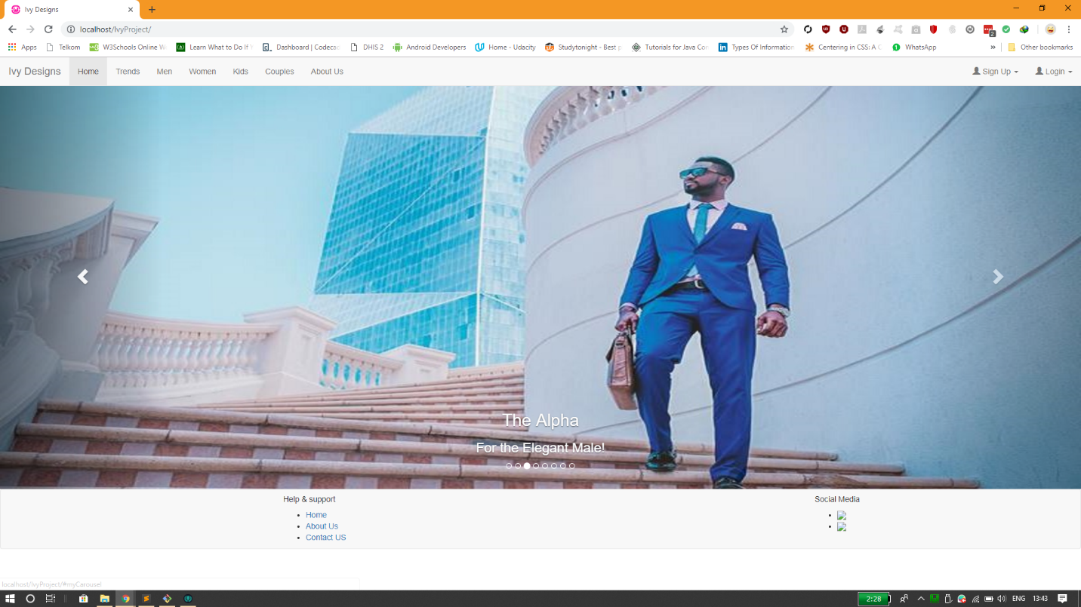

Home page

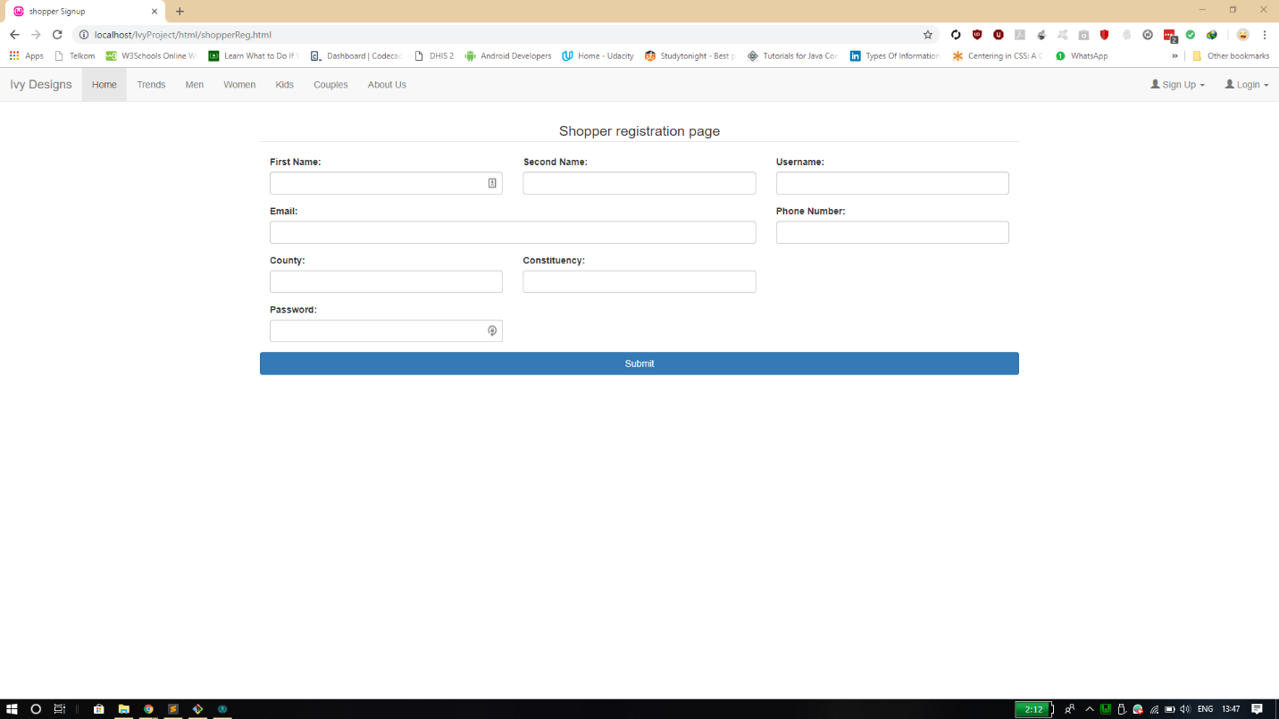

Registration page

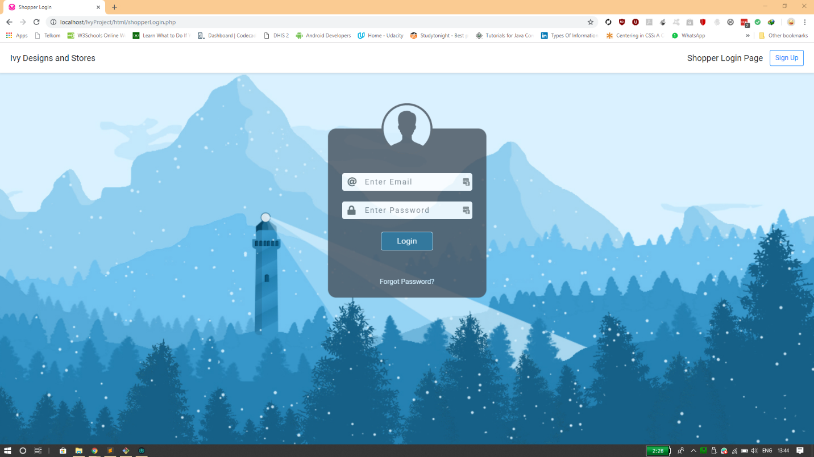

Login page

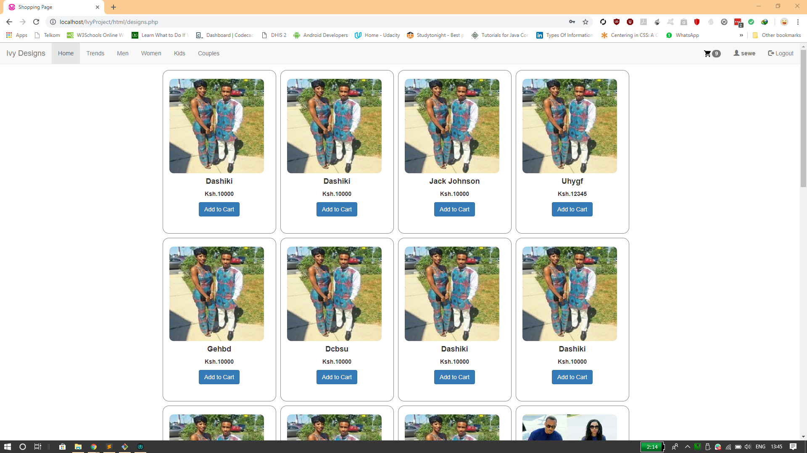

Shopping page

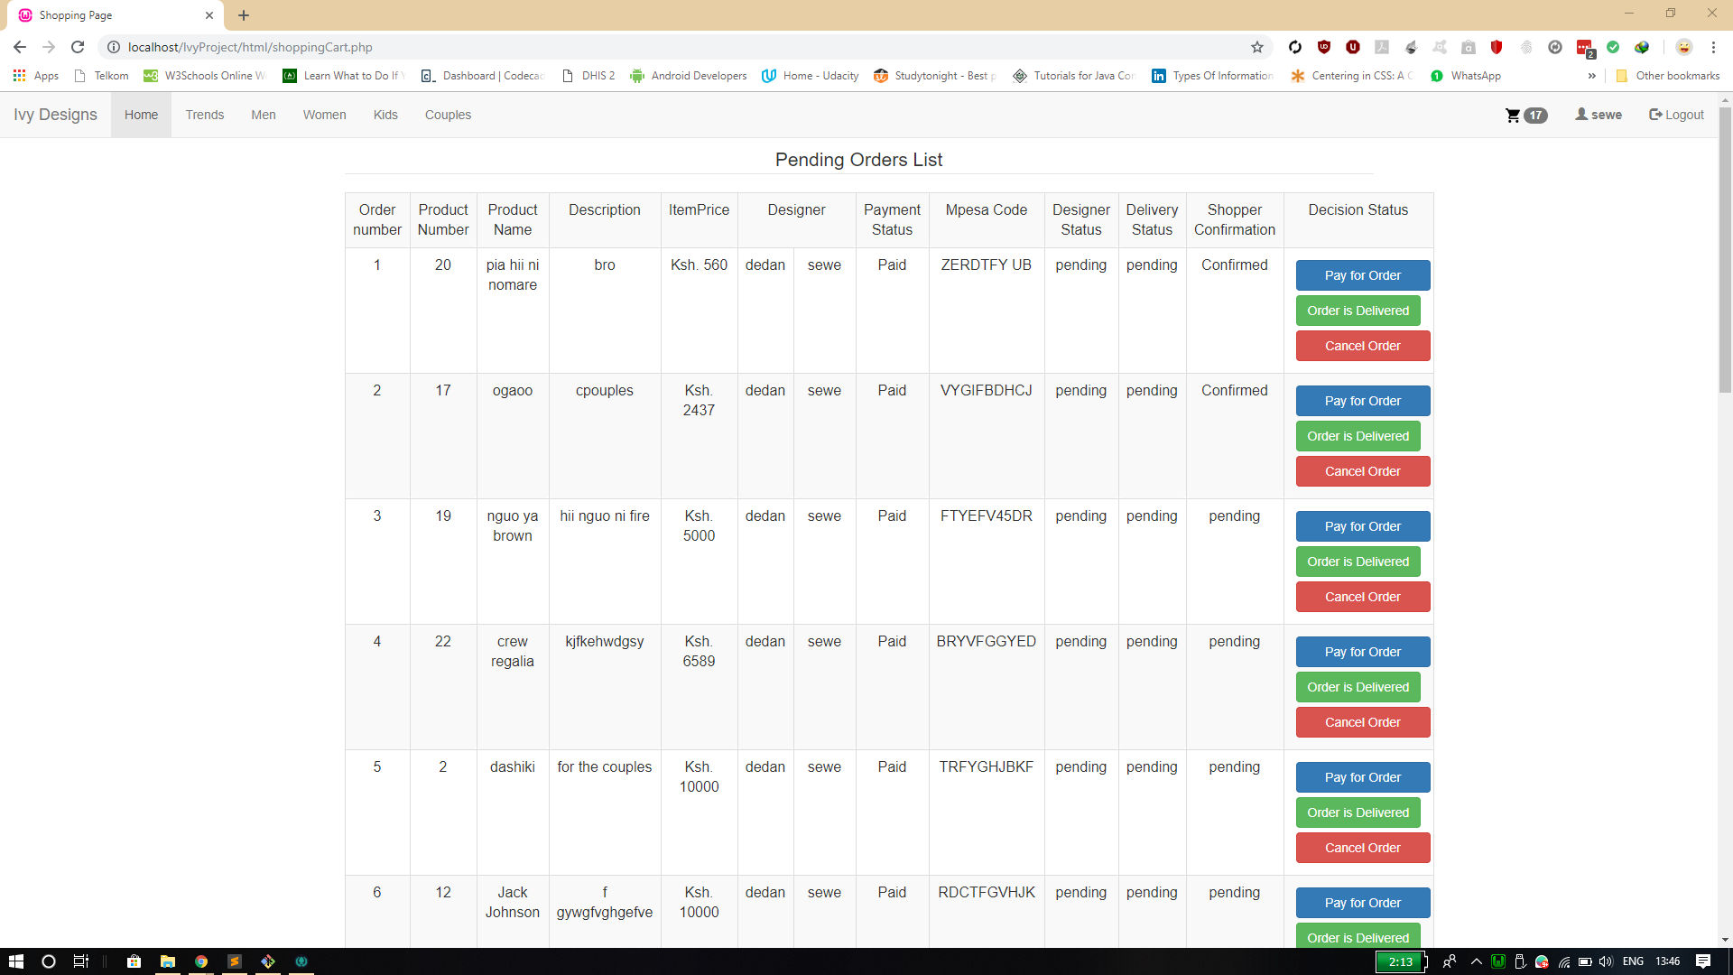

Shopping cart

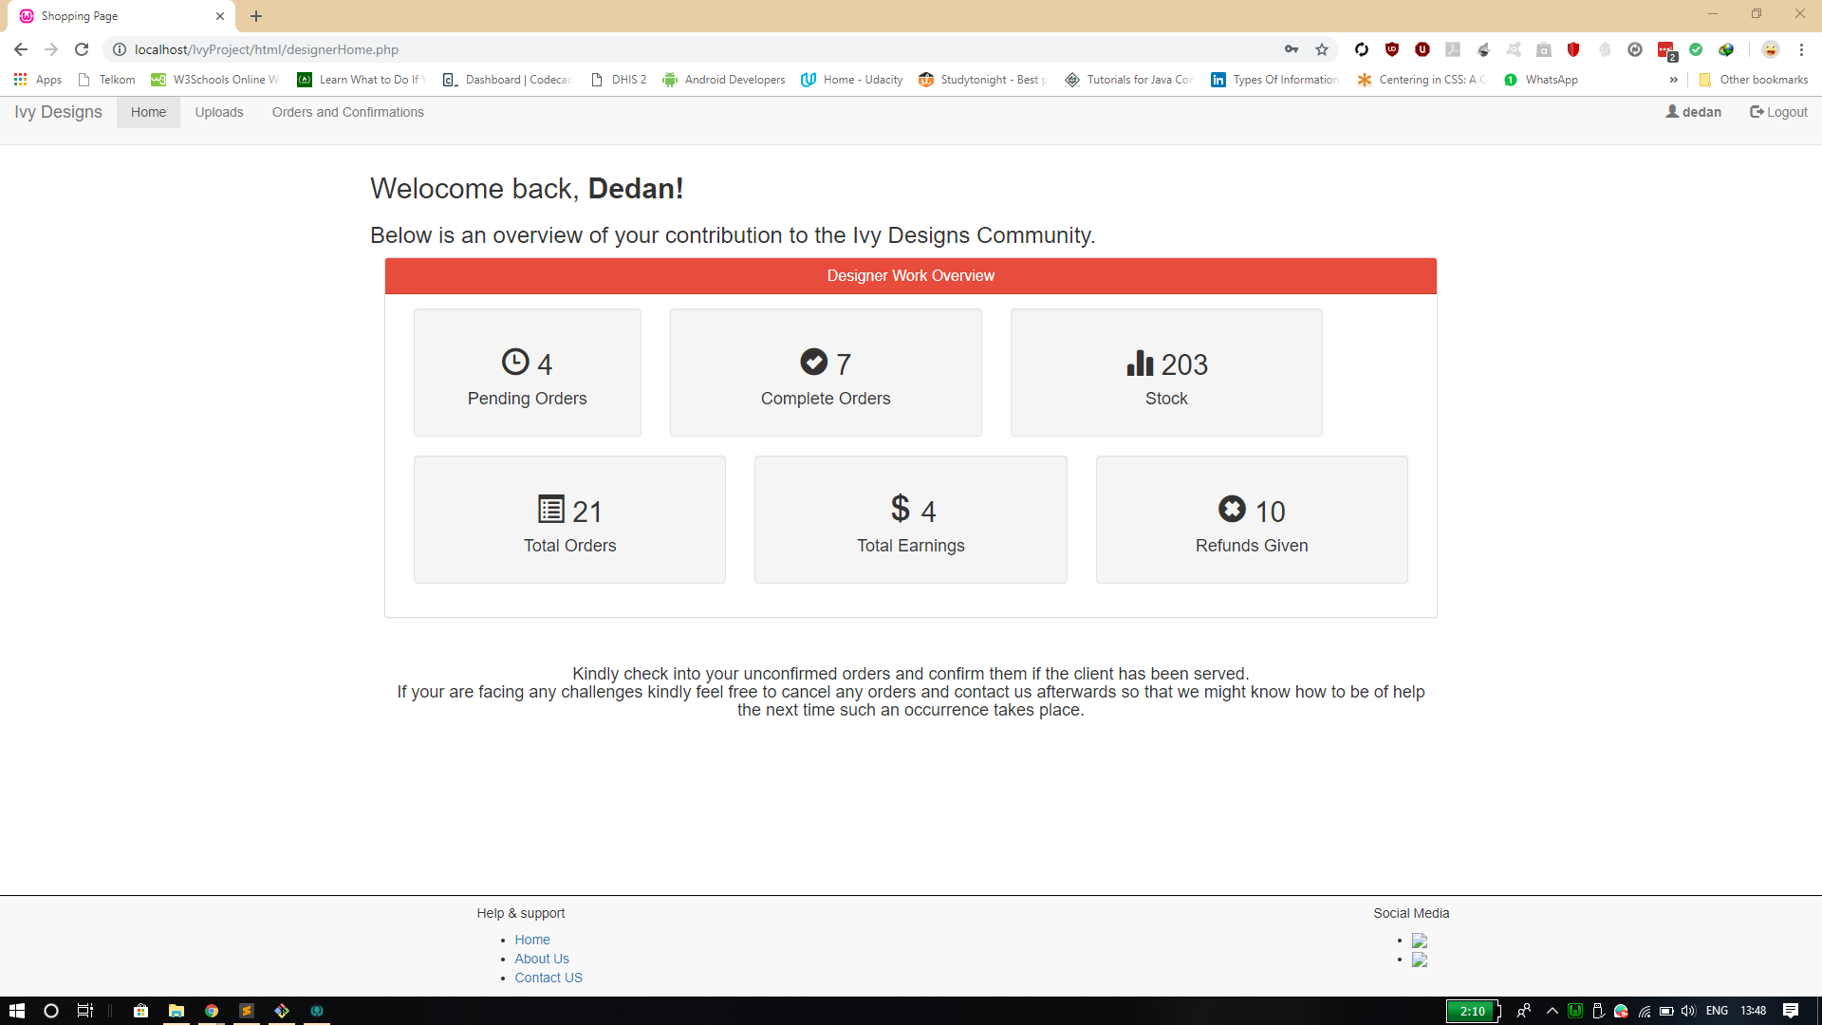

Designer home page

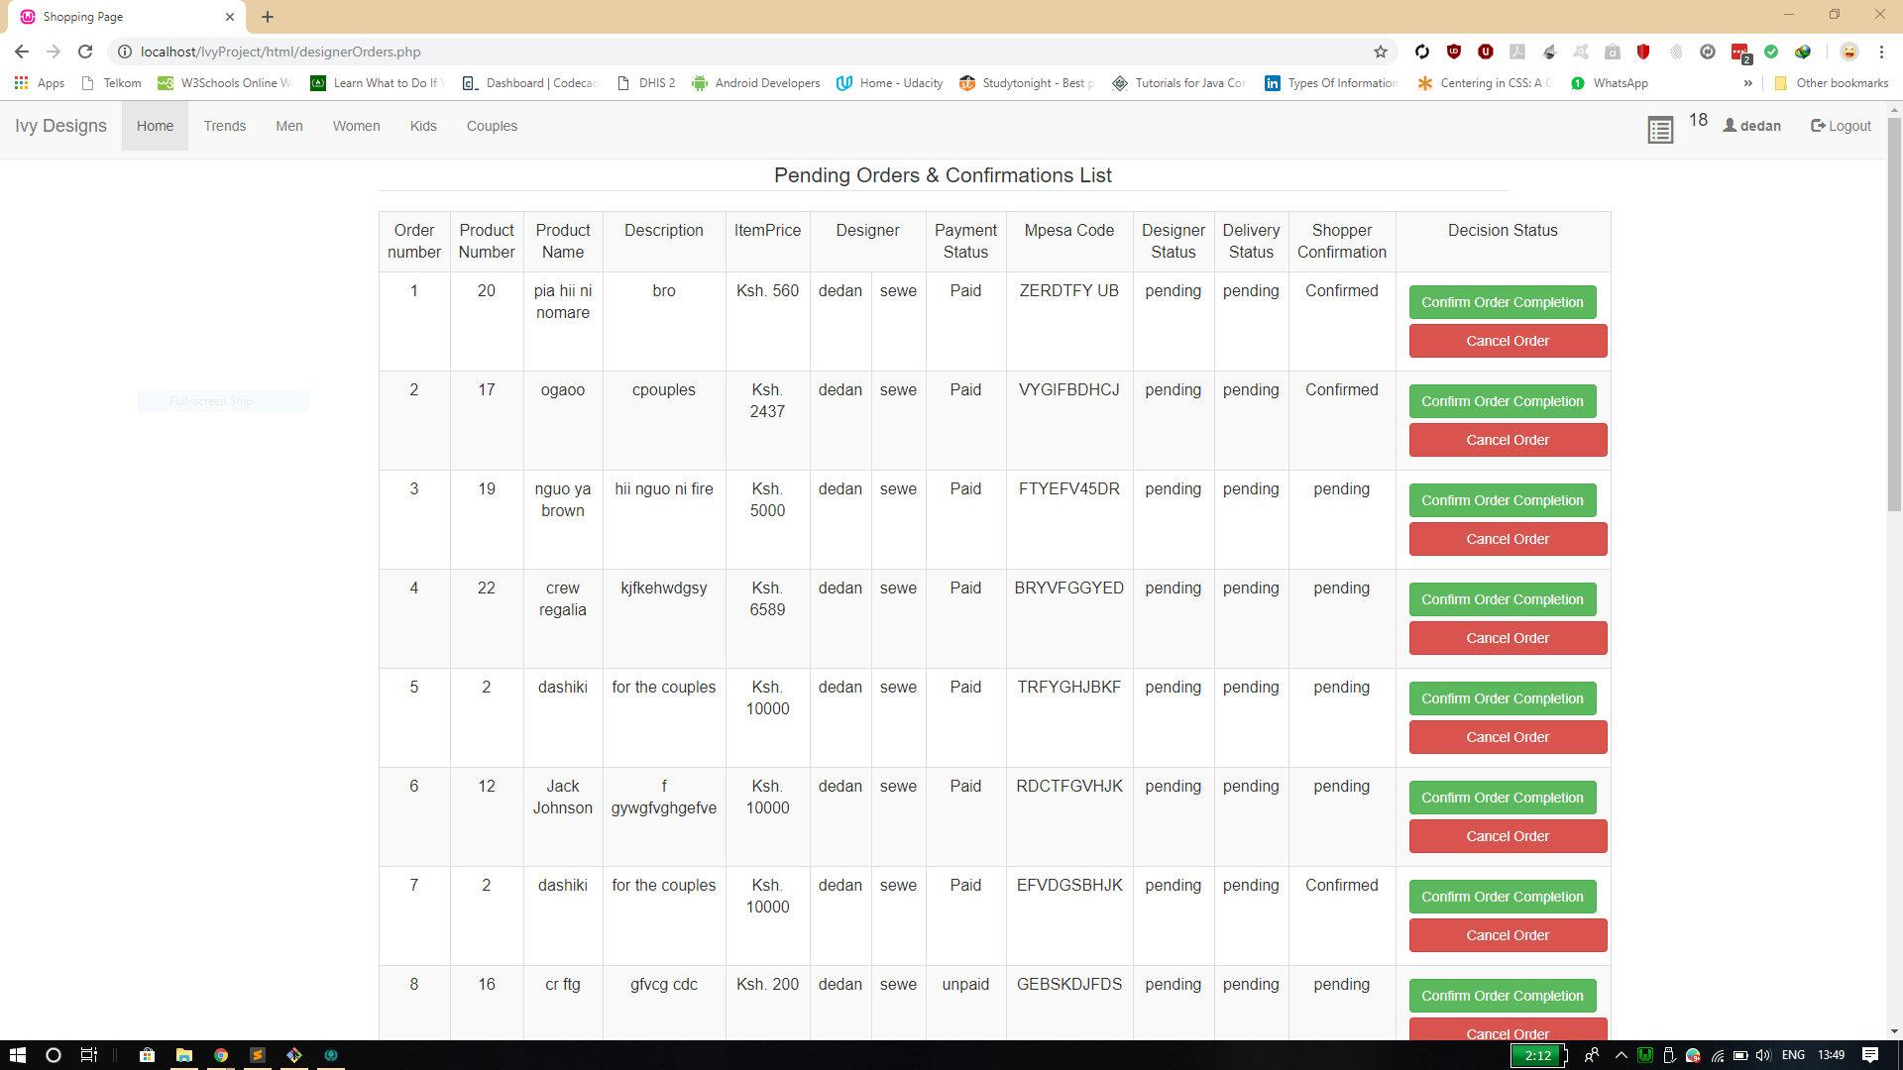

Designer order pages